**INSTRUCTION SHEET-ARIMA**

Before using the ARIMA tool, you need to download R or RStudio software in your system.The instructions for downloading can be accessed from following link: <https://cran.r-project.org/>

* To forecast the data for a product market, open that market file.
* Follow the instructions given on the next page to forecast the item for next 12 periods.
* We are demonstrating the forecast for market 1.
* Similar steps can be followed to forecast product from any other market.
* Just make sure you upload the correct market file in excel where the product you want to forecast is present

1. Open the excel file named “Arconic_Arima”. You will get to the screen shown below:

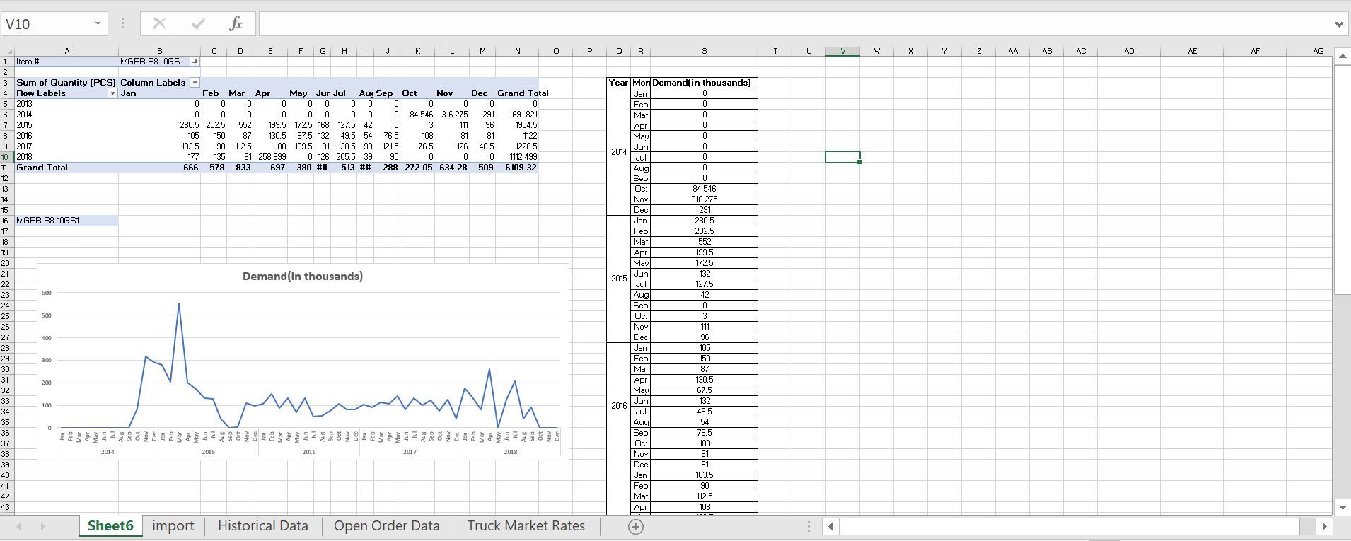 Click on the filter

1. You will see a drop-down menu on clicking the slicer

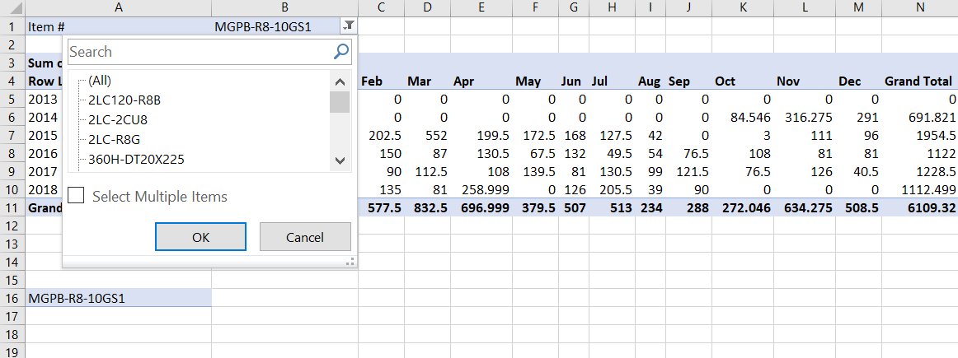 Select the item number of which you need forecast

1. Save the file after selecting the item number
2. Open R file named “Arima” on your machine. You will be directed to following screen.

**Note:** *Make sure you already have R or RStudio installed on you machine.*

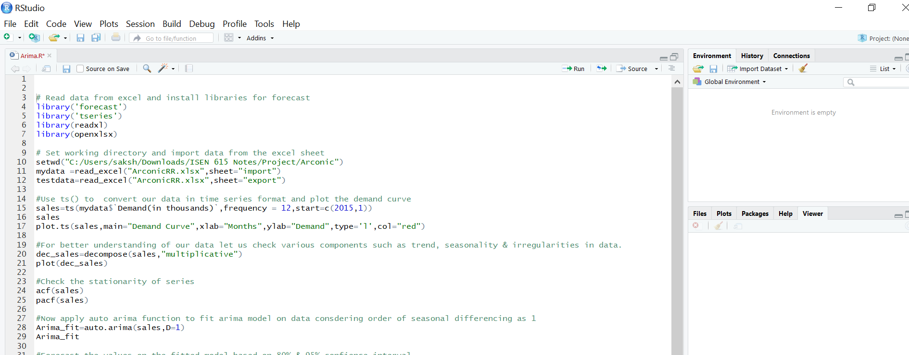

In the setwd() function write the path of the file where your excel file is saved in the format as shown.Also change the name of the file while reading the data depending upon the market.

1. 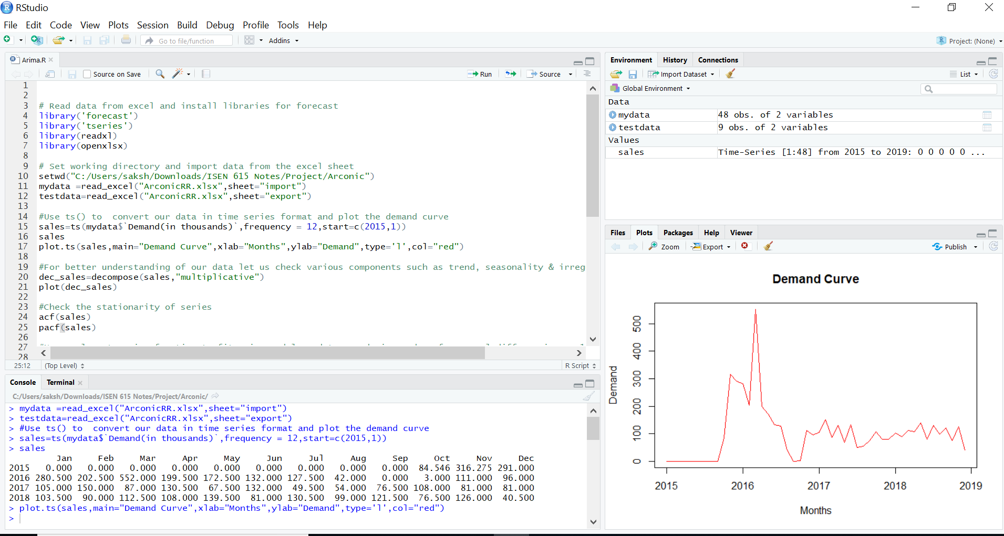This is the RStudio interface. Specify the path and name of the excel file you just saved and click on **‘Run’** button on the top right of the workspace to run code line by line or else you can run the entire code at once by pressing **Ctrl+Shift+Enter.** You can see the results of the code as shown below:

Plots are shown here

Click on Run button

Results of our code

1. By running all the codes, you will see the forecast values and plot of the particular item as shown below:

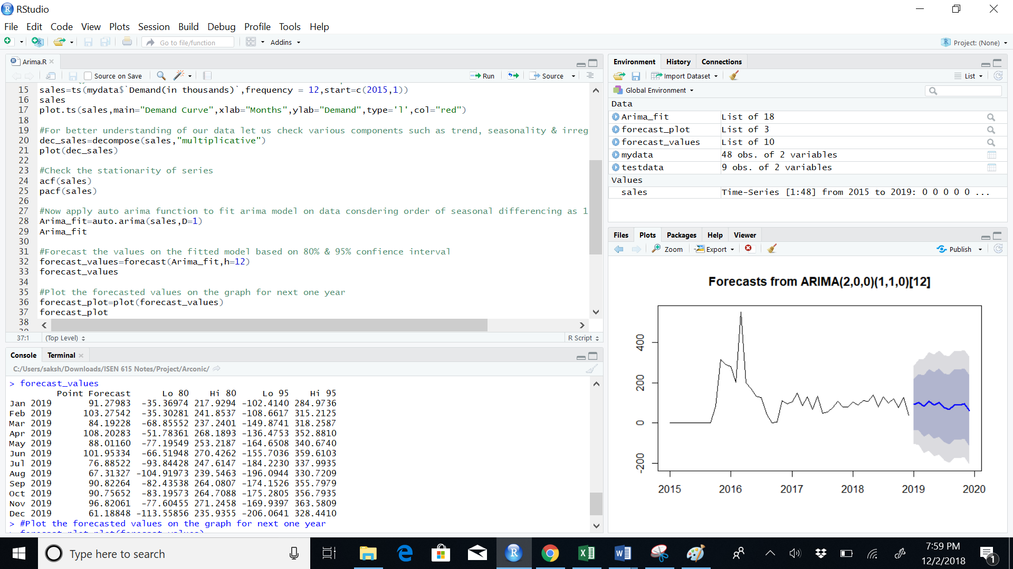

Forecast values with 80% & 95% confidence interval Forecast plot

1. To forecast for different product repeat the procedure
2. Go to excel file
3. Select the product and save the file
4. Open R and run the file